WALL PROTECTION

SIGNAGE
DECOSIGN
MORE INFO ON

new spm-international.com
SUSTAINABLE FORMULATION

MEN, WOMEN & PRM

Couple 2
H&F
Mars
Vénus
Soulier
Escarpin
Trio 2
Petit-fils
Handy

LETTERS, NUMBERS & ARROWS DIGITAL

SPECIFICATION

Letters
Play Arrows
Numbers
Ordinateur
Prise
Wifi
USB C

HOTEL & RESTAURANT


- Description: Supply and installation of customised signage (such as SPM Decosign) made of 1 or 2 mm thick rigid PVC or PVC-free material with an M1 fire-rating. The surface is matte and slightly textured or smooth, and the back is pre-adhesive. Dimensions and shapes are customisable.
- Environment: The formulation is free from heavy metals, including lead and tin (negligible values below 50 ppm), as well as CMR1 and CMR2 substances, allowing 100% waste recycling and compliance with 7 targets of the HQE approach. The level of volatile substance emissions in indoor air has been tested (below 15 μg/m³) in accordance with Decree No. 2011-321 of March 23, 2011, and its implementing order of April 19, 2011. The product is 100% recyclable.
- Model: selected by architects from manufacturer’s standard range, or supplied by architects.
- Colour: selected by architects from manufacturer’s standard range
- Installation method: Adhesive application.

Serveur
Change
Valise
Pique-nique
Transat
Cocktail
Restaurant
Café
Ascenseur
Escalier
Sortie

EVERYDAY LIFE



Pharmacie
Pilule
Poubelle
Poussette
Laverie
SPA
Recyclage

MOBILITY SPORT

Vélo
Trotelec'
Haltère
Musculation
Douche
Cintre
Vestiaire
Homme
Vestiaire
Femme


EARLY CHILDHOOD










Doe
Beaver
Bear
Rabbit
Fish
Lioness
Elephant
Giraffe
Monkey
Hippo

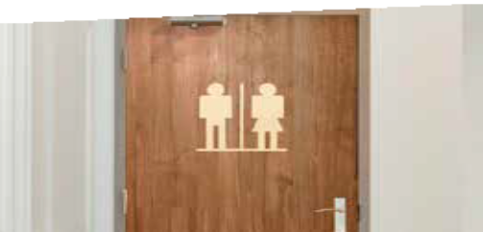






(e.g. Sienna) (e.g. Sienna)

(e.g. Bark)
(e.g. Clay)
(e.g. Poppy)
(e.g. Sand) (e.g. Granite) (e.g. Mimosa)
(e.g. Bark/ (e.g. Pebble) Sienna)

